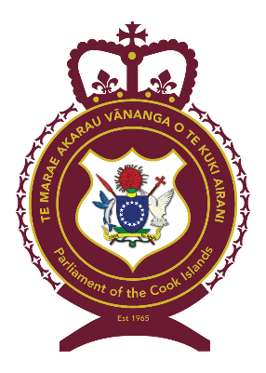

COOK ISLANDS SYSTEM OF GOVERNMENT
By Tangata Vainerere, Clerk of Parliament
7 March 2022.
-------------------------
COUNTRY NAME: Cook Islands
CAPITAL: Rarotonga (Avarua)
GOVERNMENT:
- Self-governing under Constitution (4 August 1965), in free association with New Zealand: Cook Islands is responsible for internal affairs; New Zealand has responsibility for some external affairs and defense, in consultation with the Cook Islands.

- Former Government - British protectorate (27 September 1888); annexed to the then British colony of New Zealand (11 June 1901)
SELF GOVERNANCE:
- 4 August 1965 - Became self-governing in free association with New Zealand; right to move to full independence at any time.
CONSTITUTION:
- The Cook Islands Constitution Act 1964 (NZ Parliament) – 17 November 1964
LEGAL SYSTEM:
- Tribal Customs (Pre Contact)
- Raiatea Code of Laws (1827)
- The Blue Laws (1879)
- English common law (27 September 1888)
- British and New Zealand statutes and customary laws (11 June 1901)
- Cook Islands Act 1915
- Cook Islands Constitution is the supreme law (4 August 1965) plus Acts and Regulations.
SUFFRAGE:
- Universal Suffrage (all eligible men and women 18 years or over).
OFFICIAL LANGUAGES:
- All debates and discussions in Parliament to be conducted in Maori as spoken in Rarotonga and in English.
- Every Bill and Act to be in Maori as spoken in Rarotonga and in English.
NATIONAL GOVERNMENT (THE THREE ESTATES OF POWER):
(I) THE LEGISLATURE (MAKING LAWS):
Parliament - The Parliament of the Cook Islands is unicameral and consists of 24 members elected by popular vote.
The Parliament serves a four-year term.
House of Arikis - consists of up to 24 Arikis (Chiefs) appointed by the Queen's Representative.
Function - to consider any matters regarding the welfare of the people of the Cook Islands as are submitted to it by Parliament, and to express its opinion and make recommendations to Parliament. No legislative power.
(II) THE EXECUTIVE (IMPLEMENTING LAWS):
Head of State: Her Majesty Queen Elizabeth II in right of New Zealand - represented in Cook Islands by the Queen's Representative, appointed by the Queen (3 year term).
Head of Government: Prime Minister - the Queen's Representative appoints the Prime Minister, being a Member of Parliament, who has the confidence of a majority in the Parliament.
Cabinet: Cabinet of Ministers - Prime Minister + 6 Ministers, being members of Parliament, appointed by the Queen's Representative on the advice of the Prime Minister; responsible to Parliament.
Executive Council: consists of the Queen's Representative and the Cabinet.
(III) JUDICIARY (ENFORCING LAWS):
High Court (constituted by Justices of the Peace) - Justices of the Peace are appointed by the Queen’s Representative, acting on the advice of the Executive Council and sit in the High Court by virtue of the Judicature Act 1980-81.
High Court (constituted by a Judge) - established under the Constitution, it consists of the Chief Justice and any other Judge appointed by the Queen’s Representative acting on the advice of the Executive Council.
Court of Appeal - established under the Constitution, it consists of three Judges. The Chief Justice and puisne Judges of the High Court are Judges of the Court of Appeal and other Judges may be appointed by the Queen’s Representative acting on the advice of the Executive Council.
Privy Council - Appeal from decisions of the Court of Appeal to the Privy Council is allowed by statute in certain circumstances.

